**C(**[**https://www.tutorialspoint.com/compile_c_online.php**](https://www.tutorialspoint.com/compile_c_online.php) **):**

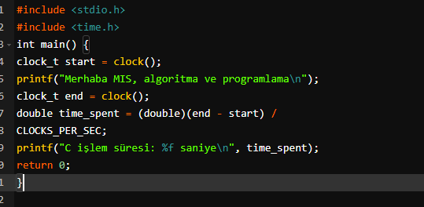



**C++(Visual Studio):**

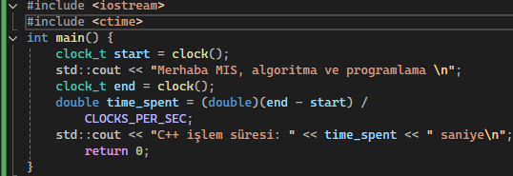



**Python(Visual Studio Code):**

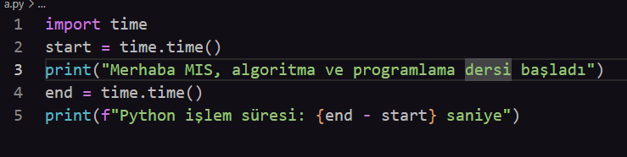



**C#( Visual Studio Code):**

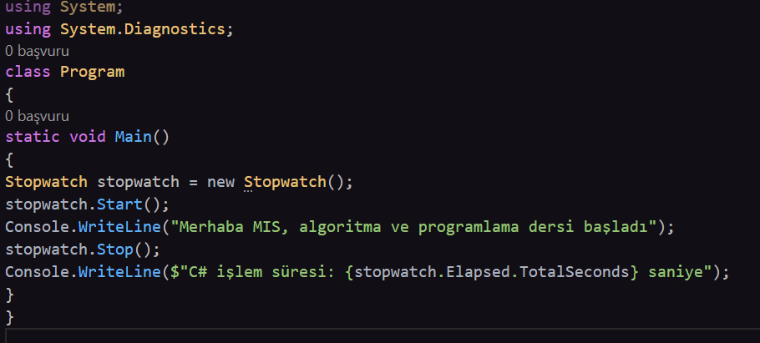



**Perl(**[**https://onecompiler.com/perl/42vawzg4g**](https://onecompiler.com/perl/42vawzg4g) **):**

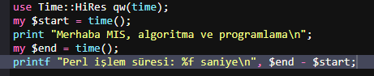

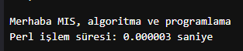

**Java(**[**https://onecompiler.com/java/42vawbhv7**](https://onecompiler.com/java/42vawbhv7) **):**

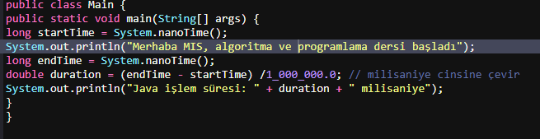



**NodeJs(**[**https://onecompiler.com/nodejs/42vaweja2**](https://onecompiler.com/nodejs/42vaweja2) **):**

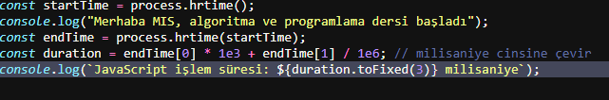

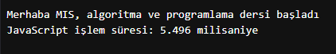

**Ruby(**[**https://onecompiler.com/ruby/42vax5kva**](https://onecompiler.com/ruby/42vax5kva) **):**

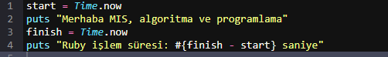



**Go(**[**https://go.dev/play/**](https://go.dev/play/) **):**

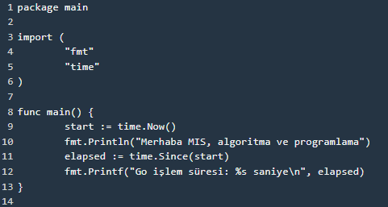



**Rust(**[**https://play.rust-lang.org/?version=stable&mode=debug&edition=2021**](https://play.rust-lang.org/?version=stable&mode=debug&edition=2021) **):**

